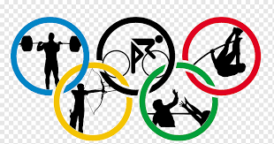 Olympic Analysis

|  |  |  |  |  |
| --- | --- | --- | --- | --- |
| Games Analysis | | | | |
| Performance | Success Factor | Host Impact | Historical Data | Impact Analysis |
| Evaluation of overall performance of a specific sporting event or championship | Analysis of factor affecting the success of the games (e.g., venue, organization, facilities). | Assessment of the impact of the games on the host city/country. | Review of historical data for the games. | Analysis of the economic, social, and cultural impact of the games. |
| Sports Analysis | | | | |
|  |  |  |  |  |
|  |  |  |  |  |
| 3.Event Analysis | | | | |
|  |  |  |  |  |
|  |  |  |  |  |
| 4.Participants Analysis | | | | |
|  |  |  |  |  |
|  |  |  |  |  |
| 5.Medal Analysis | | | | |
| Total Medal by Country | Medal Type Breakdown | Sports Comparison | Historical Performance | Gender Analysis |
| This category Provides an overview of the total number of medals won by each country, team, or player in a specific event or competition | This section details the distribution of medals by type, indicating how many gold, silver and bronze medals were won by a particular entity. | Here, the focus is on comparing the medal counts by achieved by different sports or events within a specific competition. | This category delves into the historical context of a country, team, o player’s performance in term of medals. | This section scrutinizes how medals are distributed among different gender. It can reveal patterns, disparities, or trends in terms of medal allocation |